MINUTES OF REGULAR CALLED MEETING OF THE GOVERNING BODY
OF THE CITY OF LAMPASAS, TEXAS
CALVERT MUNICIPAL BUILDING
CITY COUNCIL CHAMBERS
302 E THIRD STREET
Monday, February 2, 2026
5:30 p.m. Workshop/Regular Session
The City Council of the City of Lampasas met in Regular Session on the above date and time with Mayor Pearce presiding.

Council Members Present: City Staff Present:
Eric Hernandez Erin Harrison, Interim City Manager
Davis Keele Kayleigh Stanley, City Secretary
Dorothy Person Monica Wright, IT Director
Charlie Pratus Bailey Carter, Recreation Specialist
Mayor Pro Tem Kuehne Jody Cummings, Police Chief
Edward Gold Stephen Sewell, Public Works Director
Van Sims, Water/Wastewater Superintendent
Micah Harry, Electric Superintendent
Carlos Garcia, Streets Superintendent
Robyn White, Public Works Secretary
Lupe Charping, Parks Secretary
John Moffett, Electric Department
Council Members Absent: Kempner Water Supply Present:
N/A Bruce Sorenson
Joe Spoon
Brandon Butts
Ric Dominowski
Stella Clements
JOINT WORKSHOP

- Call to Order Joint Workshop

Mayor Pearce called the meeting to order at 5:31 p.m.

- Discussion with Kempner Water Supply Corporation.

Kempner Water Supply General Manager, Bruce Sorenson, presented the Council with a brief description of the history of the agreement with the City of Lampasas and Kempner Water Supply. In which, he included the current struggles they are experiencing with infrastructure improvement costs and the base rate they are needing to charge their customers in order to supplement the cost of the water the City of Lampasas is not contractually obligated to pay but is receiving.

Kempner Water Supply covers 400 square miles with 6,000 connections.

Kempner Water Supply would like Lampasas to entertain an amendment to the existing 2006 Wholesale Contract. Amendments to the contract would assist in solving ongoing litigations, hiring office staff, operation and maintenance in the existing plants. In addition, they are currently remodeling their plant to increase storage by one million gallons. Future projects to be considered will be the 195 to Ivy Mountain line replacement. Estimated to be a total of $9 Million. This would be a cost share with the City of Lampasas.

- Adjourn Joint Workshop Session

Council member Hernandez made a motion to adjourn at 6:39 p.m., the motion was seconded by Council member Pratus and with a unanimous vote, the motion carried.

WORKSHOP SESSION

- Call to Order Workshop Session

Mayor Pearce called the Workshop Session to order at 6:50pm.

- Discussion regarding the Lampasas County Chamber of Commerce and Visitor Center Quarterly Report (Q1).

Melissa Unger, Chamber President, presented Council with the Q1 report from the Chamber of Commerce and Visitor Center. The Visitor Center received a total of 1,191 visitors in Q1. Use of HOT funds, approved during budget workshops, is a total of $14,504.47 for this quarter.

- Discussion regarding Appendix A Fee Schedule changes for the Hostess House and Rental Contract.

City Secretary, Kayleigh Stanley, presented an updated Fee Schedule after amending the Fee Schedule discussed at the January 12, 2026 Council Meeting. An increase of $50 per fee and the weekend rental to $2,000. Mayor Pro Tem Kuehne mentioned that she would still like to see the floors individually rented. Staff expressed concern for this with vandalism.

- Discussion regarding any item on the Regular Session for February 2, 2026.

N/A

- Discussion regarding any item not included on the Regular Session for February 2, 2026, for consideration on a future agenda. No action can be taken by City Council.

Council member Person discussed her appreciation for all the supporting entities during the recent freeze we experienced. She would also like to mention that there is a new transit service coming to town and would potentially like for it to be a future agenda item discussion.

- Adjourn Workshop Session

Council member Keele made a motion to adjourn Workshop at 7:01pm, the motion was seconded by Council member Hernandez and with a unanimous vote, the motion carried.

REGULAR SESSION
- Call to Order

Mayor Pearce called the Regular Session to order at 5:58 p.m.

- Presentations and Proclamations

- Mayor Pearce announced City Employee of the Year is Kayleigh Stanley

- Resolution Proclaiming March 2026 Night Sky Awareness Month

Martha Noell would like to invite everyone to attend the Stars at Night Star Party.

- Service Recognition:
        - Ricky Haynie – Golf Course – 10 Years

1.1 | Citizen comments- Any citizen who desires to address the City Council on a matter that is not included on the agenda may do so at this time.

Deorald Finney approached the board to encourage the Council to attend the upcoming EDC meeting on Wednesday, February 11 at 5:30. They will be having a presentation from marketing professionals and would recommend that everyone attend.

1.2 | Citizen comments- Any citizen who desires to address the City Council on a matter that is included on the agenda may do so at this time.

N/A

2.0 | CONSENT AGENDA
2.1 | Discussion and possible action regarding approval of minutes of the Regular Meeting held on January 12, 2026.
2.2 | Discussion and possible action regarding the second reading of an Ordinance amending Chapter 78 (“Traffic and Vehicles”), by amending Article III (“Stop, Standing and Parking”), Section 78-223 of the City’s Code of Ordinances titled (“Parking Time Limit Generally; Exception”) Regulating the parking of vehicles on public streets; providing a repealer clause, a severability clause; and providing an effective date.

Council member Hernandez moved to approve the consent agenda, the motion was seconded by Council member Pratus and with a unanimous vote, the motion carried.

3.0 | BOARDS/DEPARTMENT REPORTS
3.1 | Public Works Annual Report for Electric, Streets, Water/Wastewater
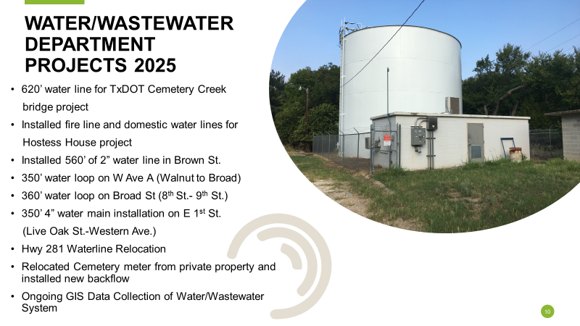
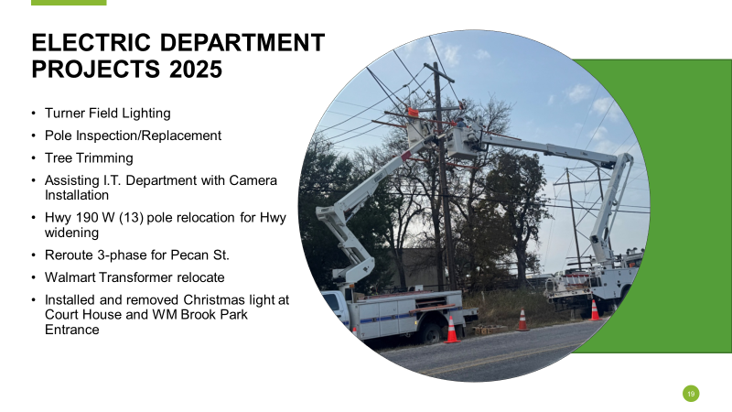
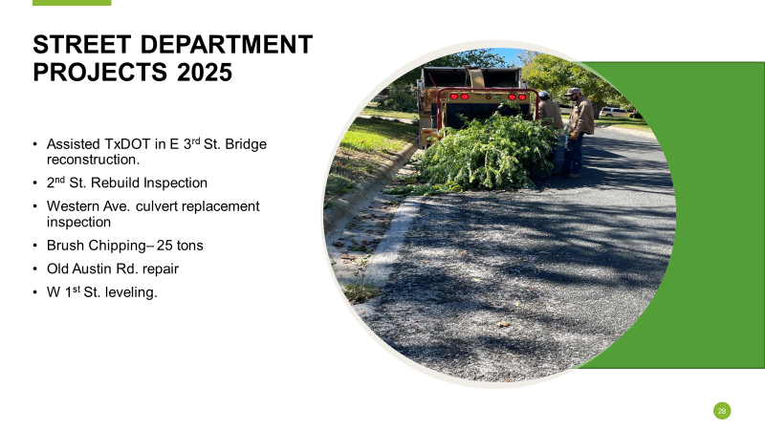

4.0 | NEW BUSINESS

4.1 | Discussion and possible action concerning approval of the Contract for Election Services between Lampasas County, Texas and the City of Lampasas, Texas, for the May 2, 2026 General Election.

Mayor Pro Tem Kuehne made a motion to approve the Contract for Election Services between Lampasas County, Texas and the City of Lampasas, Texas, for the May 2, 2026 General Election, the motion was seconded by Council member Hernandez and with a unanimous vote, the motion carried.

4.2 | Discussion and possible action regarding the first reading of an Ordinance amending Appendix A of the City code (Fee Schedule), concerning fees for Chapter 54: Parks and Recreation (Hostess House Rental Fees), providing for a repeal of conflicting ordinances; providing for repeal a severability clause; and providing an effective date.

Council member Hernandez made a motion to approve the first reading of an Ordinance amending Appendix A of the City code (Fee Schedule), concerning fees for Chapter 54: Parks and Recreation (Hostess House Rental Fees), providing for a repeal of conflicting ordinances; providing for repeal a severability clause; and providing an effective date, the motion was seconded by Council member Person and with a unanimous vote, the motion carried.

4.3 | Discussion and possible action regarding lease agreement renewal with Quadient and a new IX-5 Mailing System.

Mayor Pro Tem Kuehne made a motion to approve a lease agreement renewal with Quadient and a new IX-5 Mailing System, the motion was seconded by Council member Keele and with a unanimous vote, the motion carried.

4.4 | Discussion and possible action regarding the awarding of a bid from Texas Multi-Chem in the amount of $49,620.00 for repairs to the Turner Field Complex caused during the July flooding.

Council member Hernandez made a motion to award the bid from Texas Multi-Chem in the amount of $49,620.00 for repairs to the Turner Field Complex caused during the July flooding, the motion was seconded by Council member Gold and with a unanimous vote, the motion carried.

Adjourn into Executive Session

Council member Hernandez made a motion to adjourn into Executive Session at 7:43pm, the motion was seconded by Council member Pratus and with a unanimous vote, the motion carried.

Kayleigh Stanley and Erin Harrison entered Executive Session at this time.
Deorald Finney and Mike Gill entered Executive Session at 7:50pm.
Mike Gill left Executive Session at 8:20pm.
Deorald Finney left Executive Session at 9:00pm.
Kayleigh Stanley left Executive Session at 9:11pm.

EXECUTIVE SESSION

The City Council of the City of Lampasas, Texas will meet in closed Executive Session pursuant to the Texas Government Code, Chapter 551, as follows:

5.1 | Section 551.087 (economic development)- (1) to receive and evaluate financial information received from a business, to discuss same, and/or to deliberate regarding commercial or financial information that the City has received from a business that the City seeks to have locate, stay, or expand in or near the city, with which the City is conducting economic development negotiations; and/or (2) to deliberate an offer of any financial or other incentives to any business prospect described above.  - Project Sweet Dreams
5.2 | Section 551.072 (deliberations about real property)- Deliberation concerning the potential purchase, exchange, lease, acquisition, sale and/or value of real property.  - Lampasas Trucking and Redi-Mix: 1550 N Highway US 281  - Sixth Street between Avenue J and Avenue I
5.3 | Section 551.074 (personnel matters), to deliberate the appointment, employment, evaluation, reassignment, duties, or discipline of a public officer or employee; City Manager and other personnel matters as allowed by Texas Government Code, Chapter 551, et seq.
5.4 | Adjourn Executive Session and Reconvene Regular Session
Council member Hernandez made a motion to adjourn Executive Session and Reconvene Regular Session at 9:16pm, the motion was seconded by Council member Pratus and with a unanimous vote, the motion carried.

REGULAR SESSION
6.0 | ACTION ON EXECUTIVE SESSION
6.1 | Discussion and possible action concerning items posted and/or items posted by Council for Council’s Consideration in Executive Session

Council member Gold made a motion stating in accordance with the notice given by the City Manager on January 23, 2026, to Lampasas Trucking and Redi-Mix, due to the company’s unfortunate inability to comply with the terms of their 2014 lease to purchase agreement with the City of Lampasas and the 2014 Lampasas Economic Development Corporation, I move to terminate both the lease to purchase agreement and economic development agreement with Lampasas Trucking and Redi-Mix located at 1550 N US Highway 281 and direct the City Manager to seek damages and reimbursements for the provided economic development incentives, professional fees and remediation expenses associated with the project located at said address. Additionally, the property must be vacated by the lessee by March 23, 2026 at 5:00pm, the motion was seconded by Council member Pratus and with a unanimous vote, the motion carried.

Council member Keele made a motion to remove ‘acting’ from Erin Harrison’s Finance Director title and allow staff to execute all documents to appoint Harrison as the Finance Director, the motion was seconded by Council member Hernandez and with a unanimous vote, the motion carried.

Adjourn

Council member Pratus moved to adjourn at 8:42pm. The motion was seconded by Council member Gold and with a unanimous vote, the motion carried.

PASSED AND APPROVED this ____________day of __________________________, 2026.

_________________
Herb Pearce, Mayor
ATTEST

______________________
Kayleigh Stanley, City Secretary

